DIGITAL TWINS UNDERSTANDING

## ARCHITECTURE:

SWAN Digital Twin Architecture diagram gives a framework for categorising a digital twin’s main elements. This architecture framework can function as a checklist and lets you see the components and gaps you have to complete your digital twin.  
  
if you want to decide which infrastructural investments to make in your utility for the next five years, you don’t need a live update of sensor data and events. You need aggregated information of which are the critical areas in your infrastructure. However, if you want to make operational decisions like whether to turn off and on a pump and for how long, you want all the live and forecast data you can get your hands on, and you might even want to know what the possible consequences are. These decisions require different dynamic data and different granularity of the digital twin.

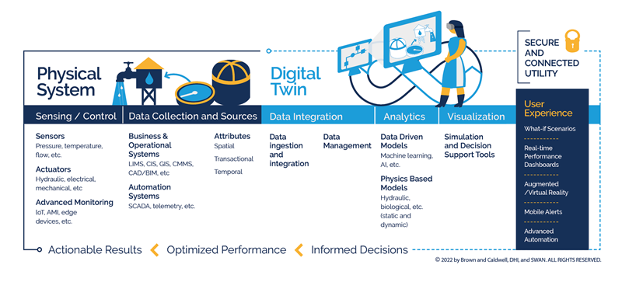

## EVALUATE MY DIGITAL TWIN:

## 4 MAIN PILLARS OF DIGITAL TWIN

 We identified four main pillars of a digital twin that can help guide your way to evaluate your digital twin and how to proceed further. These pillars are – Outcomes, Technology and Connectivity, Insights, and Interactions and Actions. 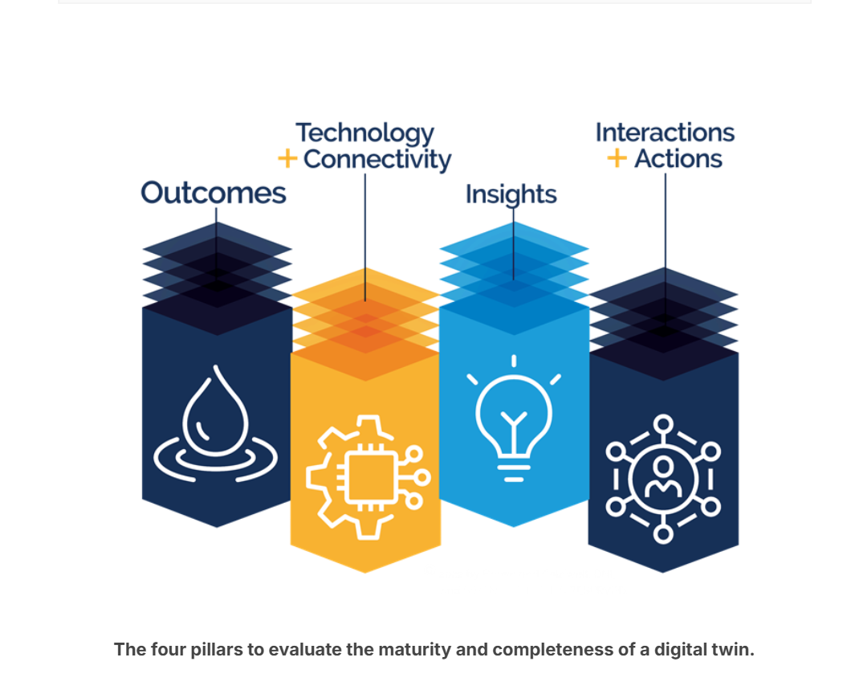

1. Outcomes pillar:  Some examples are improved regulatory compliance, lower-cost operations, and a more reliable and resilient system. These outcomes should be as quantifiable as possible so that they can be used to track digital twins’ performance and plan further development.

2. Tech and connectivity: a utility with high connectivity and high technology will be able to provide a digital twin with more real-time data, making the digital twin more reflective of the actual operational conditions. It will also enable a digital twin to provide more intelligent decision support and advanced automation.

3.Insights: measure of information produced by models in the digital twin. They can be generated by analysis of simulations from data-driven or artificial intelligence (AI), physics-based models, or a combination of them. Insights give you an idea of what is happening, what has happened and what will happen in your system. Some analysis examples are anomaly detection, what-if scenarios, predictive operational parameters

physics-based models (e.g., hydraulics models) excel in simulating expected design operating conditions in a utility, while a data-driven model simulates patterns in actual operating conditions  
4. Interactions and Actions:  these actions can be for staff, including operators, engineers and managers. This support can be suggested setpoints or suggested work orders to create.

 Digital Twins can supplement programmable logic controllers (PLC) and provide intelligent control automation or a co-pilot to the operations team. This operational co-pilot enables operators to control devices like pumps and valves more dynamically and in more discrete time steps under their direct supervision.  
  
Getting started with DT

**The digital twin journey, a scalable and flexible approach to planning, designing and implementing digital twins.**  
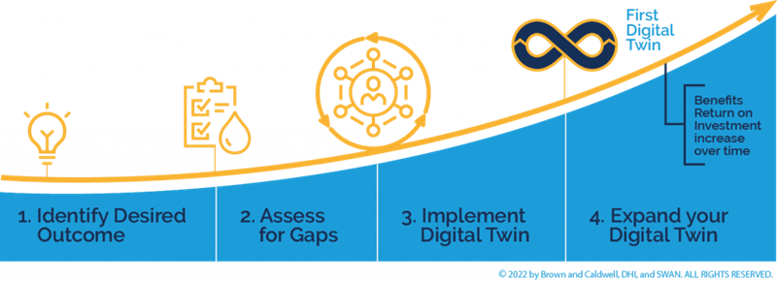

**Identify – decide what you want**: We recommend starting small, looking for low-hanging fruits, and making the goal as actionable as possible. This will be the guiding star of the direction of the digital twin.

**Assess – what you have in your utility**: get an inventory of technology, initiatives and projects that can help you achieve the goal you have identified because it provides a framework that covers a high-level overview of the different components of a digital twin.

**Implement –** **an iterative approach and involve different stakeholders :** Set some success criteria and comm. with others to understand the goal and metrics to measure. Review the metrics and iterate the implementation.

###this approach will work for all digital twins in the water sector.  
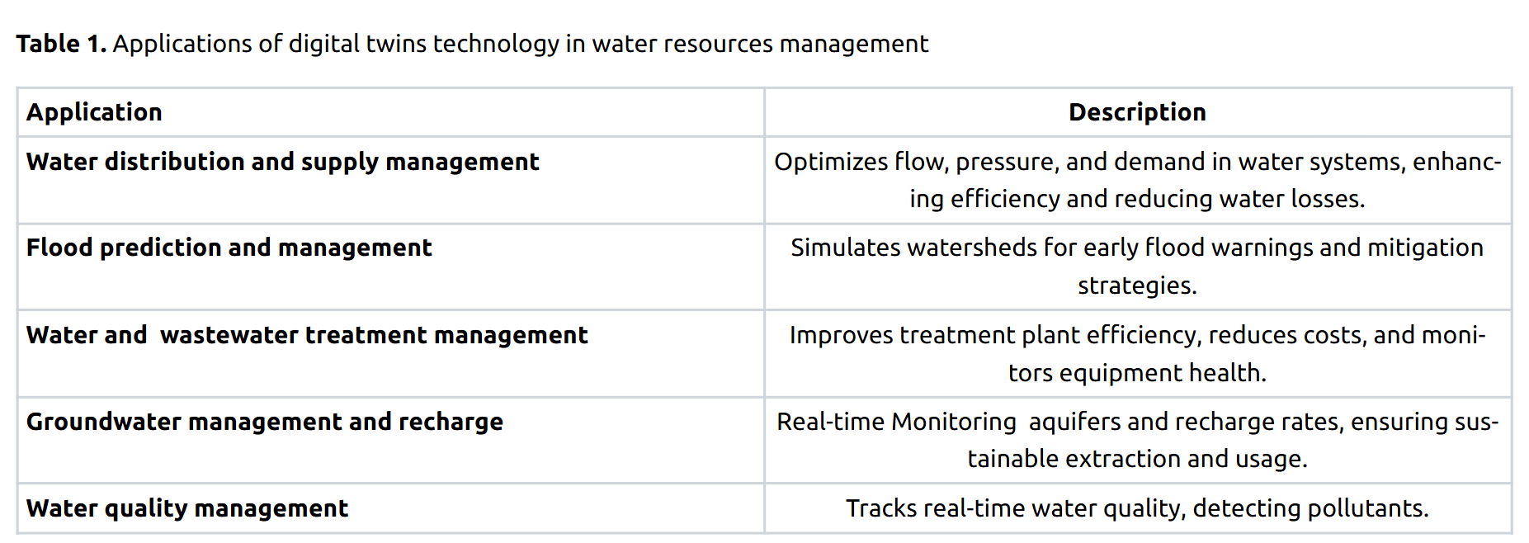

**1. Water Distribution and Supply Management**

**Water distribution systems are vital for providing water for different users and sectors, especially in populated cities with high demand.**

* Helping the operators to select the optimal decisions in real-time by simulating the effect on any operation prior to taking the action in the real system.
* Employ energy-saving strategies, such as using a fewer number of pumps when demand falls below a dynamically chosen limit.( switch one motor on for taking water to a single tank then other if more consumption of water per hour only then, tanks connected to each other, keep a primary tank and a primary source of water to the tank, use mainly that unless required)
* Identifying anomalies to establish an enhanced maintenance system, providing diminishing  maintenance costs and downtime to limit disruptions to end-users.
* Optimizing the operation of the system in order to improve the quality of the service and the water quality.
* Developing emergency response plans and modeling the behavior of the system under emergency conditions for detecting an early warning system against possible contamination into the network.

Pipes and pumps are intricate systems with complex internal mechanisms and exact control requirements, necessitating careful safety measures. They play a crucial role in maintaining the flow, pressure, and control of fluids in various processe. They can also become one of the major sources of water losses, through leakage.

Digital twins technology, in conjunction with machine learning (ML) and the internet of things (IoT),  can control and reduce the water losses, including  flow management, water, and energy monitoring, along with water grid control, to work together to boost the efficiency of water distribution systems.  Using a detection and communication system, water losses can be reduced through intelligent supervision of sensors, telemetry, and actuators that control water pressure and flow at critical network points

The integration of a remote-control platform, powered by big data analytics, allows water-energy network managers to optimize system performance through real-time control and data-driven decisions, progressively improving the overall efficiency of the network.

\

gathers data from sensors in pipes, pumps, and valves, facilitating simulations that predict water flow, pressure, and quality. Early detection of leaks and blockages can be facilitated by this technology, enhancing repair response times and reducing water loss. It supports predictive maintenance, allowing the Public Utilities Board (PUB) to preempt equipment failures, thus minimizing disruption

By analyzing weather data and consumption patterns, it adjusts to demand fluctuations. Additionally, it helps in developing smart water grids, ensuring better resource allocation

2. Groundwater :  
Digital twins for groundwater monitoring can monitor real time data  from sensors distributed across the aquifers, aiding in decision making by identifying areas that require automated water pump drainage and sending signals through the internet to activate the water pumps based on the groundwater table  value, maintaining the table value levels under the surface. The model also includes features such as historical data visualisation based on previous sensor readings and a predictive machine learning model to predict ground water level based on historical precipitation data.

3.Water quality management:  
digital twins that can monitor, predict, and communicate water quality dynamics by combining contaminant fate and transport models, online sensor data assimilation, and real-time visualization and response capabilities. In the context of watershed-scale water quality, digital twins provide innovative features for real-time response, enabling real-time monitoring, prediction, and management of water quality hazards such as algal blooms, chemical spills, and combined sewer overflows

Water management using Digital Twins Research paper:  
this paper systematically discusses the concept and development history of digital twin smart water conservancy, compares its differences with traditional water conservancy models, and further proposes the digital twin smart water conservancy five-dimensional model

The research progress of digital twin smart water conservancy is summarized by focusing on six aspects:

1.digital twin water conservancy data perception, transmission

2.data analysis and processing

3.digital twin water conservancy model construction

4. digital twin water conservancy interaction and collaboration

5.digital twin water conservancy service application

6.the challenges and problems of digital twin technology in the application of smart water conservancy

digital twin is oriented to the whole life cycle process of the product, which is a kind of technology that makes full use of the model, data and intelligence and integrates multiple disciplines to play the role of a bridge and link connecting the physical world and the information world to provide more real-time, efficient, and intelligent services

proposes the digital twin smart water conservancy five-dimensional model, which contains five dimensions of water conservancy physical entities, water conservancy perception data, ubiquitous real-time interaction, and digital empowerment services. Based on this model, this study reviews the research progress of digital twin smart water conservancy in six dimensions: water conservancy data perception, data transmission, data analysis and pro cessing, digital twin water conservancy model construction, digital twin water conservancy interaction and collaboration and service application 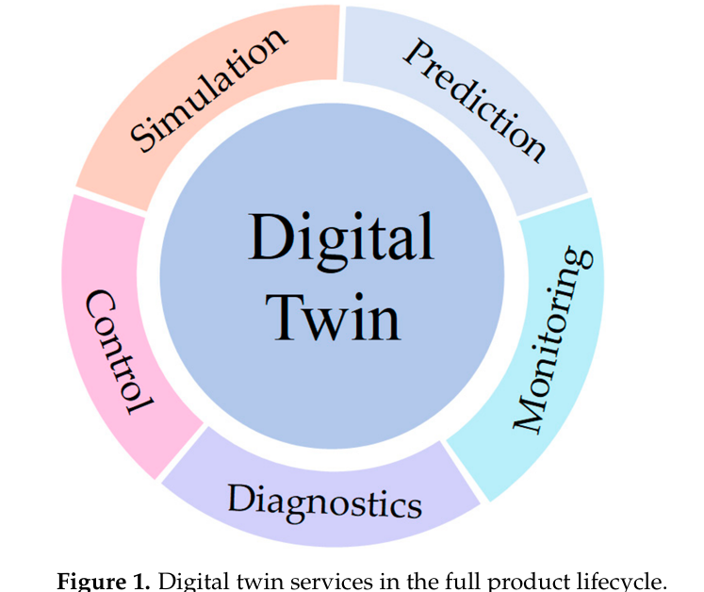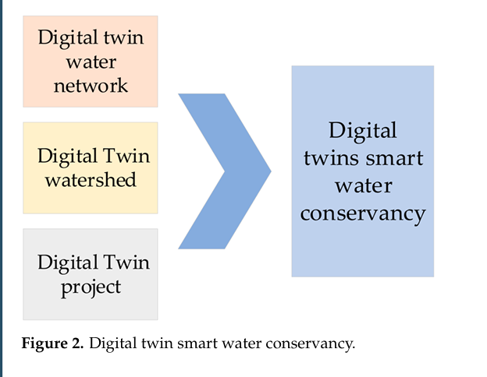

Start of the paper*:

Ministry of Water Resources has proposed a digital twin water conservancy project, digital twin water network and top-level design, so that the digital twin watershed, digital twin water network and digital twin water conservancy project come together to form a digital twin smart water conservancy series—the three factors are physical watersheds, physical water networks, and physical water conservancy projects in the digital space of mapping; the three relationships determine the relationships between the three physical entities; and the three physical entities are inter-related. The relationship between the three is determined by the inter-relationship of the three physical entities, which are not alternative to each other, have their own focus, are relatively independent, are interconnected, and conduct information sharing ?????

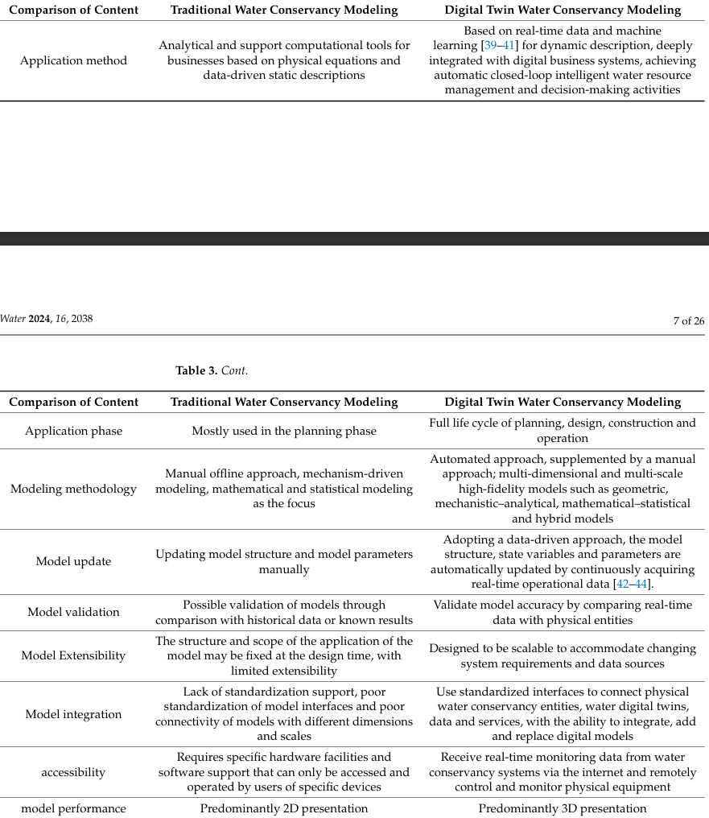

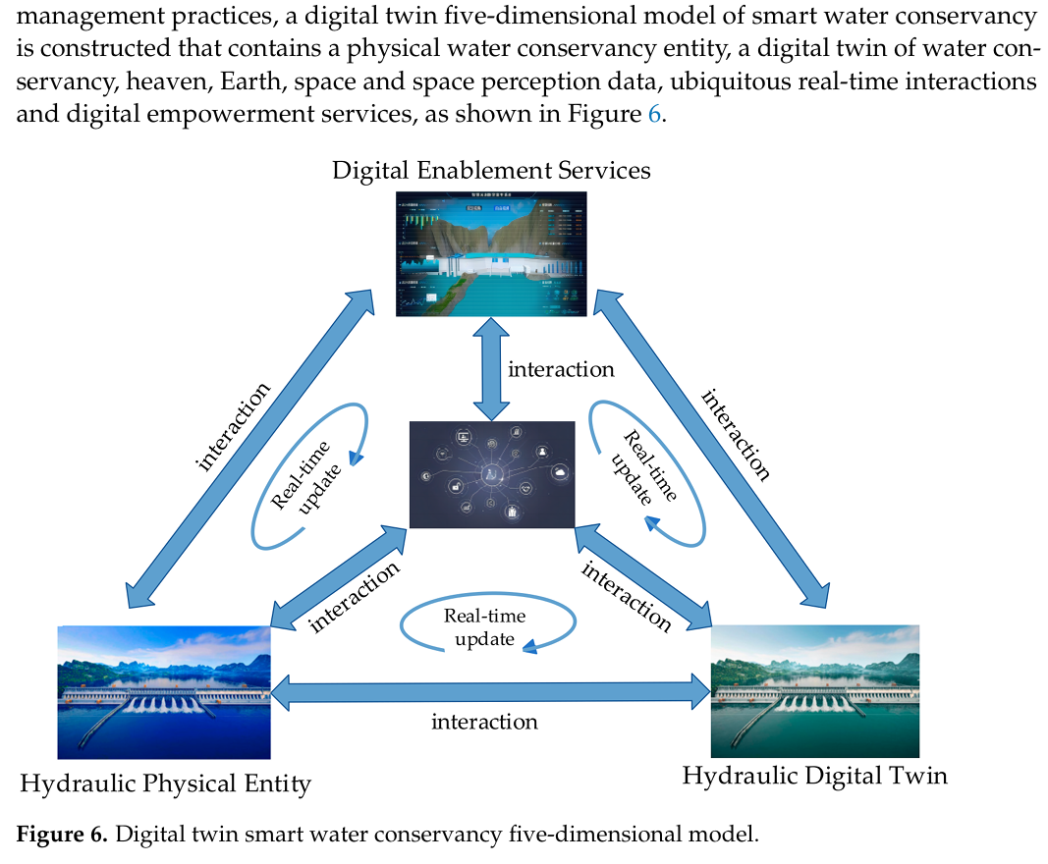

• **Water Conservancy Physical Entity**:  
Real-time data from physical water conservancy infrastructures (topography, equipment, construction impact areas) are collected using integrated air, sky, and ground monitoring systems. These include IoT sensors and devices feeding data into digital twin systems.

• **Water Conservancy Digital Twin**:  
A comprehensive virtual model of the water conservancy system is built using geometric, analytical, statistical, behavioral, and visualization models to represent the physical entity dynamically across multiple dimensions and time scales.

• **Heaven, Earth, and Space Perception Data**:  
Sensor-collected data, essential for digital twin operations, may have errors due to environmental influences and transmission loss. Thus, preprocessing and data fusion techniques are required for accuracy and integration.

• **Ubiquitous Real-Time Interaction**:  
A networked infrastructure (including IoT, internet, control systems, and protocols) enables real-time, secure, and efficient data exchange between physical systems and their digital counterparts for collaborative and optimized control.

• **Digital Empowerment Services**:   
Application layer of the digital twin system serving various stakeholders (authorities, operators, public) with solutions in water resource management, flood control, project monitoring, and risk early warning.